*Q1. What is Machine Learning?*

* Machine learning is a subset of artificial intelligence.
* It allows computers to learn from data and improve over time without explicit programming.
* Algorithms analyze large amounts of data to find patterns or make predictions.
* Common examples include product recommendations, spam detection, and image recognition.
* In simple terms, it’s about teaching computers to learn from experience, just like humans do.

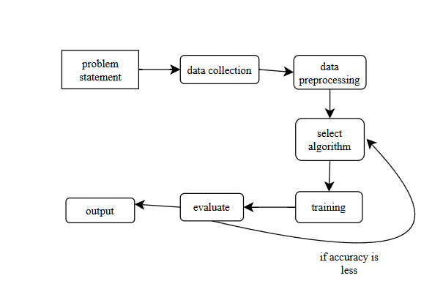

*Q2. What is supervised machine learning algorithm?*

* A supervised machine learning algorithm is a type of machine learning where the model is trained using labeled data-that means each example in the training set includes both the input features and the correct output or label.
* The algorithm learns to find patterns and relationships between the input data and the output labels, so it can predict the correct output for new, unseen data.
* There are two main types: classification (predicting categories, like spam or not spam) and regression (predicting continuous values, like house prices).
* Supervised algorithms are widely used in applications like email spam detection, image recognition, and predicting stock prices

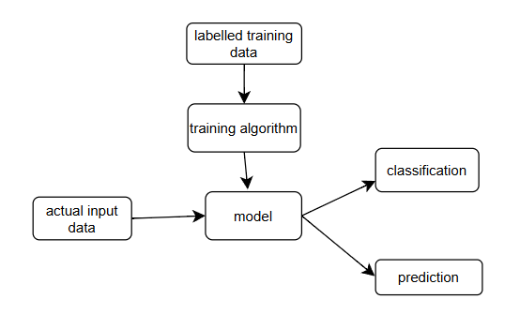

*Q3. What is regression and classification?*

* **Regression** is a supervised machine learning technique used to predict continuous numerical values based on input data. For example, predicting house prices, temperatures, or sales figures are regression problems because the output can be any value within a range.
* **Classification** is also a supervised machine learning technique, but it is used to categorize data into predefined, discrete classes or labels. Examples include identifying whether an email is spam or not, or predicting if a tumor is benign or malignant-the output is a specific category, not a number.
* In short, regression predicts *numbers*, while classification predicts *categories* or *labels.*

